Ozone Generator

Operating

Manual

Dear Customers,

Many thanks for your choice of our ozone generator. Your satisfaction is our continuous motivation, we will provide you with the best service from beginning to end. This series product come with high quality and good performance. in order to facilitate your usage, please carefully read this manual carefully before operation, and according to the manual steps, welcome to inquire and provide valuable advice, if you have any questions. Because of possible product improvements, your purchase product’s introduction maybe completely consistent, hereby apologize.

1、Preface

1.1、Scope of use

Ozone machine is high-tech environmental protection appliances, this series integrated with power protection, sound and light warning, output concentration regulation, is widely applied to air and water purification, disinfection, sterilization.

1.2、Using Environment

1.2.1、Ambient temperature：-10℃~37℃；
1.2.2、Ambient humidity：≤55%；
1.2.3、There shall be no flammable and explosive gas and conductive powder dusts in the room. It’s not permitted to install the equipment in a place where alkaline air is easy to leak or with risk of explosion.
1.2.4、The ground for equipment installation must be horizontal, and the equipment shall be placed on ground or supports steadily.
1.2.5、There must be draft fan or air conditioner to keep air dry and the operating
environment in good ventilation.

1.3、Characteristic

1.3.1、Unique air-cooled cooling technology, Timer (5G-10G); adjustable ozone output (15G-200G)
1.3.2、Stainless steel 304 external housing, atmospheric and beautiful, durable;
1.3.3、High conversion efficiency, low energy consumption, long service life;
1.3.4、Air-compressor integrated
1.3.5、Clean dry air feeding, CE certificate

- Technical Parameters
Model  Parameter | Ozone capacity （g/h） | Cooling way | Demension (mm) | Net Weight （kg） | Power（w） | Voltage | Cooling water flow
QLA-2G | 2 | Air cooled | 230*180*420 | 4 | 35 | 220v/50Hz | /
QLA-3G | 3 |  |  | 4.5 | 60
QLA-5G | 5 |  |  | 5 | 80

Note: because of the different conditions of using location, the technical parameters listed above may be deviation.
3、Functions & Operation Instruction
3.1、Functions
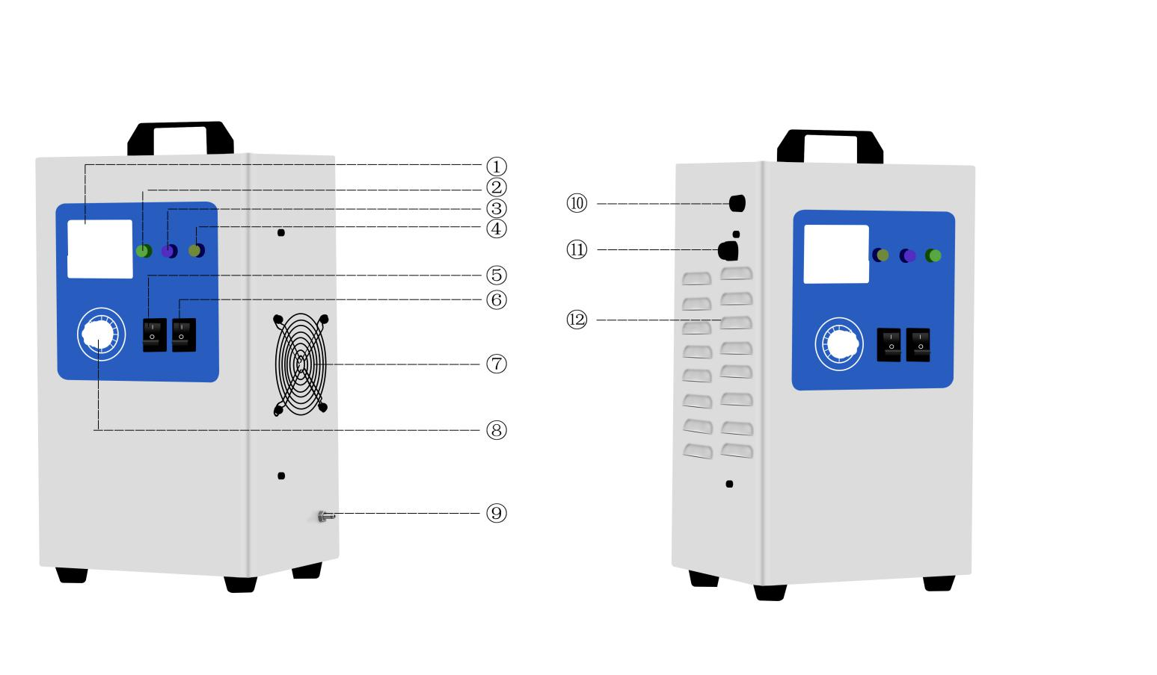
①Current/Voltage ②Power light ③Ozone light ④Pump light ⑤Ozone switch ⑥Pump switch ⑦Cooling fan ⑧Consistency control/timer ⑨Ozone outlet ⑩Fuse ⑪Power input ⑫Thermovent

Air cooling type control Panel
3.2、Operation Instruction

3.2.1 Choose the right concentration of ozone machine to different work environment and purpose, please contact our staff if advice is needed.
3.2.2 Placed the machine at good heat dissipation and ventilation location,make sure silicone hose connected well with ozone outlet. Put the silicone pipeline into disinfected ozone at high location. Prohibited to place the ozone machine inside disinfection space. when used for water treatment, put the silicone tube at least 1.5 meter high place to prevent backwater in case of damage to the equipment;
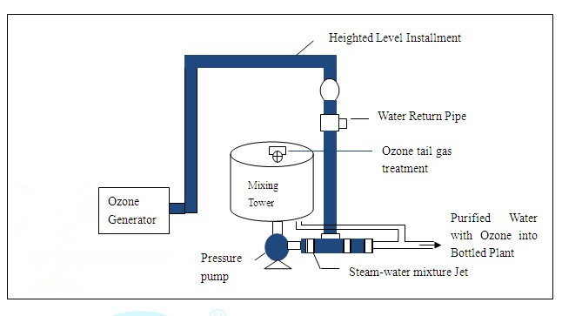
3.2.3 To achieve the best effect of disinfection, please use it in a closed and unoccupied area.
3.2.4 Plug in power, observe the power indicator light on the panel; press pump switch, the pump light is on and start work, ampere meter displays the current, dry air gas from ozone outlet;
3.2.5 Prolonging 30 seconds, turn on ozone switch, the ozone indicator on, the machine start produce ozone gas ( for 15g/h-200g/h above ozone machine, you can get different ozone capacity by adjusting concentration switch);
3.2.6 Manually shut down after reaching sterilization time; shut off ozone switch and delay 30 seconds, then close the air pump switch, pull the plug out at this time;
3.2.7 Ozone in indoor generally automatically after 1-2 hours is decomposed into oxygen, if a man may have to stay indoors for a long time, need to do protection measures for inhaling overmuch ozone
3.2.8 When disinfection is completed, please remove the ozone machine to dry ventilated place, avoid high temperature, high humidity environment and in the water, since theses factors affect the performance of ozone machine;
3.2.9 The equipment is not used for a long time, must be placed in dry ventilated place.

4、Safety considerations
4.1 This series of products using 220V/50Hz AC power source, if the voltage and frequency fluctuation range is heavy, may cause damage,abnormal or equipment failure;
4.2 The power cord plugs should keep in contact with the socket firmly, otherwise may cause abnormal electricity or even get an electric shock, endanger personal safety;
4.3 Users should regularly check the power cord; Don't let the standing legs, or other heavy objects live on the power line ; Please be careful when moving machine, don't roll or damage the power cord; replaced a new one when the power cord was damage;
4.4 Please do not use in a environment with explosion danger products;
4.5 High voltage inside the machine, it is strictly prohibited to open the back door,touching, or putting hands inside the machine;
4.6 When it don't work or need to do the maintain, unplug the power. Strictly prohibited to spray, rinse with water.do not place it in the damp, not ventilated place in case affecting the product electric insulation performance;
4.7 Prohibited to remove, modified this product, maintenance must be conducted by a professional or trained personnel;
4.8 Please do not use this product near the high precision electronic equipment,as wave interference may cause wrong operation or other problems;
4.9 Avoid excessive damp, water or other liquid go into this product may cause leakage or other faulty.
4.10 Avoid using volatile solution or organic solvent cleaning the equipment, it might damage the surface of equipment;
4.11 Using qualified safe and reliable grounding connected to avoid eliminate fire hazards;
4.12 Forbidden staff working in the high concentration of ozone space,necessary protective measures must applied when it must go inside..
5、Warranty and Maintenance
Warranty terms:
After sale service commitment：
5.1 All products (not including consumable material, accessories and the series products) from our company are warranted for one year and lifetime maintenance from the date of purchasing.

5.2 The following occasions are excluded from the warranty, and our company may charge for the repairing materials.

5.2.1 Damage due to natural disaster or other majeure reasons;
5.2.2 Product damage by human during transportation;
5.2.3 Product damages due to unauthorized operation unless instructed by our company or our authorized distributor;
5.2.4 Product damages due to high humidity working environment or flooded by water;
5.2.5 Fail to provide proof of purchase or warranty card.

5.3 If on-site service is required, customer will be required to pay for the cost of traveling, and our company or distributor can decide to come or not according to the distance.

5.4 In the case of sterilization standard is not met due to improper operation or malfunction of the product, our company does not take any responsibility.
5.5 Maintenance
(1) Fan filtering net cleaning/replacement: the dust net needs regular cleaning due to accumulate
dust from the air (refer to the maintenance cycle table below). Turn off the power before cleaning,and take off the cover of the fan. Then take out the stainless steel fan filtering net, clean it with clean water, and do not re-assemble it until it is dry.

(2) High voltage parts water removal: during humid season, there is moisture on connecting cable of the transformer (the high voltage unit), transformer, and the connecting cables of the ozone module. Dry it with cloth and hair dryer. Otherwise, it may lead to damage of the equipment.

(3) Ozone module inner chamber, discharge tube cleaning/ replacement: accumulate small partialon the inner chamber and electrode from the gas source will lower the ozone production and concentration. Hence, they need to be cleaned regularly.

5.6 Maintenance cycle table

Item | Content | Circle |  |  |  |  | Remark
 |  | month | Half year | One year | Two year | Three year
Fan filter net | Clean  replace | ☆ |  | ● |  |  | Cycling clean
Dry moisture on high voltage parts | Clean | ☆ |  |  |  |  | Maintain during humid season
Inner side of internal and external electrode | Clean |  |  | ☆ |  |  | Regular clean when used in beverage and food industry
Internal electrode | Replace |  |  |  | ● |  | Replace if high demanded
External electrode | Replace |  |  |  |  | ● | Replace if high demanded

Note:
(1) ☆：means inspection, adjust or clean; ●：means replacement
(2) The above table is the suggested maintenance/ replacement cycle from manufacturer and customer can also conduct the maintenance/replacement according the actual operation environment and intensity of work
(3) All maintenance/replacement can only be conducted when the power is off and pressure release,ensuring the safety of the operation personnel.

Number | Problem | Analysis | Inspection
1 | No power | 1、power plug loose  2. No power from  power socket  3、 fuse burn | 1、tighten plug  2、input right voltage  3、replace fuse
2 | No flow from ozone outlet | - Gas source is  - not connected  - Internal piping leakage  - Internal piping folded | - re-connect gas source  - reconnect the piping  - Check if there is leakage in the connectors,and tighten it if any is found
3 | Water store inside machine | - backwater into machine  - High humidity | - dry inner machine  - Adding air dryer

Note:
If the problem still exists after the above inspection, please contact our company or local distributor.
All maintenance/replacement can only be conducted when the power is off and pressure released,ensuring the safety of the operation personnel.

Appendix 1.（3-10G Ozone Generator Electrical Diagram）
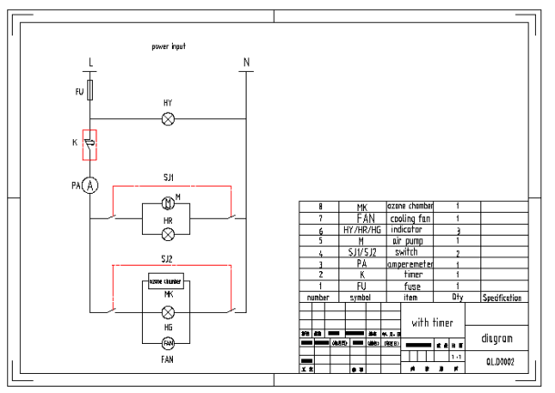
Appendix 2.（15-200G Ozone Generator Electrical Diagram） 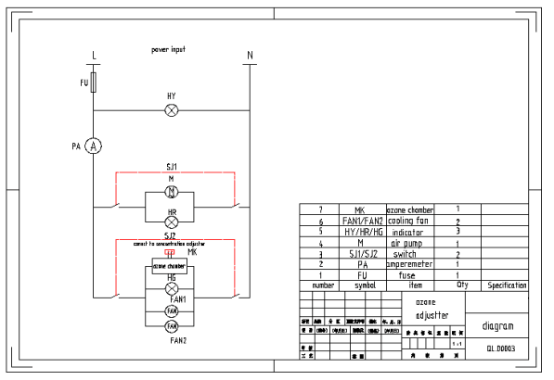

Warranty Card

Purchaser |  | Purchase Date
Contact Person |  | Telephone & Email
Address |  | Post code
Product Name |  | Series Number
Client Signature |  | Distributor Signature

Please fill in the table and send the card to our company.
After receiving this form, we will confirm to you and the warranty is valid

