QLA-500MG OZONE GENERATOR OPERATION MANUAL
Product details:
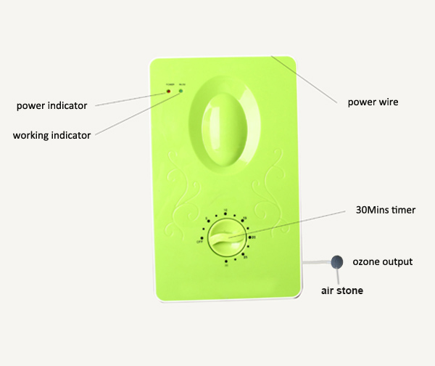

Technical parameter:

Voltage:AC 220VV/50Hz
Power:18W
Ozone output:≦500mg/h
Maximum time:30 mins
Dimension:16.5*5.5*27cm
Net Weight:1KG/unit
Pakage: 20units/carton
Carton Dimension:73*37*35cm

Applications:

Health care:
Application scope | Function & effect | Time setting
Dental Hygiene | Brush teeth with ozonic water day and night,can eliminate mouth odor,prevent mouth ulcers. | 5 minutes
Skin disease prevention | Wash hands,feet,or take a shower with ozonic water,can prevent fungal infection and skin itching;purify skin;maintain beauty and keep young. | 15 minutes
Aquarium sterilization,oxygen  increasing,anti-disease | Moderate O3 put into water,not only can remove impurities,such as bacteria,heavy metal,organic compounds,etc.but also increase oxygen in the water,enhance fish vitality and metabolism.Different fish different adaptability,please do a test before using machine to purify water. | 5-10 minutes  (according to water volume)
Drinking water  purification,homemade mineral water | O3 can decompose water impurities,such as bacteria,heavy metal,organic compounds,and decolor water increasing oxygen,purify water. | 10 minutes  (10kg)
Cloth disinfection,odor removal and purification | Ozonic water can purify dirt in cloth surface,reduce consumption of water and detergent;disinfect and sterilize in washing process,reduce water pollution;No chemical detergents left on cloth to cause skin irritation. | 10-20 minutes
Home life:
Application scope | Function & effect | Time setting
Fresh preservation, anticorrosion | Frozen meat easily encourages the growth of bacteria without appropriate treatment during thawing.If it is put into ozonic water,which can inhibit bacterial breeding,keep meat original flavor,achieve the effect of preservation and sterilization. | 5-10 minutes
Meat hormone decomposation | Ozonic water can decompose antibiotic,hormone in meat,such as chicken,pork,etc. | 10-20 minutes
Feeding bottle,tableware disinfection & sterilization | Soak knife,fork,bowl,chopsticks and feeding bottle in ozonic water after washing,can prevent disease infection,such as hepatitis. | 10 minutes
Fruit and vegetable disinfection & sterilization | Ozonic water can both decompose pesticide residues in fruits & vegetables and eliminate bacteria on the surface. | 10-20 minutes
Refrigerator deodorization and fresh food preservation | It’s effective in a short time when applied to refrigerator deodorization,fish fresh in storage room,suppression of odor diffusion,etc. | 10 minutes

Air purification:

Application scope | Function & effect | Time setting
Air purification in living room,bedroom,etc. | Keep air clean and fresh by removing smoke & dust,decomposing harmful substance and killing dust mites. | 10 minutes
Bath room deodorization,kitchen fishy smell removal | Efficiently eliminates pungent odor in washroom,oil fume odor and fishy smell in kitchen room,etc. | 10 minutes
Pet,rubbish odor removal | Pet body smell sometimes is unbearable,but after sterilization and deodorization by ozone,it will be much better;On a rubbish dump,easy to breed mosquitoes,flies and other insects,while using O3 to purify,can keep air clean an fresh. | 10 minutes
Wardrobe,shoe cabinet deodorization & mould proof | Use O3 to disinfect sneakers, leather shoes,socks,can not only remove odor but also prevent fungal infection;When the seasons change,it easily occurres mildew and odor on cloths in the wardrobe,O3 can solve this problem,because it is disinfectant & deodorant. | 10-20 minutes
Formaldehyde & methylbenzene & odor removal in new decoration house and furniture | Decomposes harmful gas,for example,formaldehyde & methylbenzene,in new furniture and new decoration house(natural volatilization needs 3 years plus),reduces the source of human allergens. | 30 minutes

Effect of ozone sterilization:
Ozone is a powerful oxidant and bactericide,so nowadays,it’s widely used in air and water disinfection & sterilization in many fields,such as fruit and vegetable fresh-keeping,drinking water purification,room air purifying and so on.
O3 sterilization test report:
Bacterial culture method:bacteria plate culture
Experiment temperature:25℃
Experiment ozone concentration:0.10ppm

Time  content | Bacteria survival percentage
 | 1 minute | 2 minutes | 5minutes | 10minutes | 20minutes
Bacillus coli | 38% | 17% | 0.3% | 0% | 0%
Typhoid bacilli | 46% | 22% | 0% | 0% | 0%
Gonococci | 32% | 10% | 0% | 0% | 0%
Staphy Lococci | 35% | 11% | 0% | 0% | 0%

Operation instruction:
1.Plug in the power,working indicator turns red,this moment is standby mode.
2.Connect silicon tube with air stone,then put air stone into the container bottom which you are gonna use(If it is for air treatment,air stone is unnecessary).
3.Turn the knob clockwise,working indicator turns green,this moment it has entered the working state,then you can choose working time according to timer arrow.If you want to shut down machine ahead of time,just turn the knob counterclockwise to ”OFF”.When working time is over,working indicator turns back to red.

Accessories:
Please check accessories in the package:
Name | Operating manual | Air stone | Silicon tube | Certificate of quality
Quantity | 1 | 2 | 2 | 1

Caution:
1.When using for water treatment,machine must be placed higher than water surface, to prevent water flow back to machine,causing damage.
2.Do not let machine working under the condition of 42℃ above,smoke,moisture,etc.to avoid
bad effect on ozone output and shorten machine life span.
3.Do not let eyes,respiratory tract have direct contact to ozone outlet,when using machine
for disinfection & sterilization.
4.When using machine for air treatment in a closed space,people must leave there,and enter again 30-40 minutes later after machine stop working.
5.When using machine for disinfection & sterilization,if you feel uncomfortable,too strong irritant or dizzy,please stop operation.
6.Do not drink ozonic water directly,water treated by ozone should be used after 20-30 minutes or after o3 have gone.
7.Unplug when doing maintenance.
This device applies to 220V/50Hz power supply,not to other power source.Do not expose to rain or water splatter,to avoid fire hazard or electric shock.Do not keep machine under high temperature or wet place.
There’s high voltage inside machine when it’s working, strictly forbidden to open case to repair or refit device,any problem caused by disassembling by yourself,should be your responsibility.

Failure counter measures:

Malfunction | handling method
Under normal working condition,ozone gas reducing or no gas out of air stone. | Please check silicon tube if it’s folding or broken,if so please change another one or put it straight.
 | Please check air stone if it’s clogged,if so please change another one.If the above problems not exist,but the fault still there,please contact distributor or manufacturer for help.
Under normal working condition,gas comes out but without the smell of ozone | Please contact distributor or manufacturer to solve the problem.
In normal use,indicator light dosn’t work | Please check if power supply is in good condition,if it’s plugged in well;if the socket is loose,please change another one.After that,if it’s still can not work,please contact distributor or manufacturer to solve it.
Warranty:

- Please keep this warranty card properly for maintenance proof.
2.Warranted against defects in materials and workmanship for a period of 12 months from the date of purchase.
Product name
Model |  | User info.
Purchase date |  | Purchase quantity
Adress |  | Phone

