CAUTION: READ INSTRUCTIONS THOROUGHLY BEFORE OPERATION OF UNIT

Ozone Generator

Manual

Dear Customers,

Many thanks for your choice of our ozone generator. Your satisfaction is our continuous motivation, we will provide you with the best service from beginning to end. QLO series product come with high quality and good performance. In order to facilitate your usage, please carefully read this manual carefully before operation. Welcome to inquire and provide valuable advice, if you have any questions. Because of possible product improvements, your purchase product’s introduction maybe not completely consistent, hereby apologize.

1. Safety notes:

1.1 Safety precautions

- Qualified special ground cable, reliable grounding, and safety grounding are required, otherwise electric shock and other dangers may occur.
- Ozone is strong oxidizing gas. The ozone system must be shut down when there is ozone leakage, then check the leakage point and repaired it before restart the system.
- Staff is prohibited to enter the space when the machine is being used for space sterilization.
- The equipment can not be installed in area with high moisture or smoke, to avoid potential danger.
- Unauthorized disassemble, movement and reassembly are prohibited.
- The equipment can only be installed by qualified personal.
- Improper installation may lead to ozone leakage, electricity short circuit and fire.
- The equipment must not be installed in area with risk of Ammonia leakage or explosion.

1.2 Important notes:

- installation personal must be qualified technician and maintenance personal must be trained.
- The equipment must be prevented water go into inside.
- Prohibited to open the equipment control panel and cabinet due to high voltage inside.
(4) Make sure input and output pipe are connected correctly. Otherwise it may lead to leakage or damage of the equipment.
(5) Don’t use any damage parts, otherwise it may lead to accidents or damage to the device.
(6) User must not change electrical cables or power connector unless authorized.

1.3 Operation notes and maintenance

- Don’t not rinse the equipment
- The power source should be disconnected during not-operation period.
- Make sure the drain valve are working normally, and filters with regular maintenance
- Keep the ambient area clean, dry , with ventilation device installed.
- Don’t damage the wiring cable, otherwise it will occur electric shock.
- Inlet and outlet must not be blocked; otherwise equipment performance will be lowered and out of order.
- Keep the external of the equipment clean.
- During long non-operation period, the power source should be disconnected and the equipment should be cover with plastic sheeting.
- To ensure safety, maintenance can only be conducted with equipment power off.

1.4 Operation environment

(1) Ambient temperature：-10℃~37℃；
(2) Ambient humidity：≤70%；
(3) There shall be no flammable and explosive gas and conductive powder dusts in the room. It’s not permitted to install the equipment in a place where alkaline air is easy to leak or with risk of explosion.
(4) The ground for equipment installation must be horizontal, and the equipment shall be placed on ground or supports steadily.
(5) There must be draft fan or air conditioner to keep air dry and the operating
environment in good ventilation.

- Product Introduction

2.1 Product description

The QLO ozone generator used heat-resistant quartz glass or enamel ozone chamber which is extremely stable, long lifespan, high discharge efficiency, and not easy to damage in case of back flow water. This product have been designated product for many domestic and internal well-know company.

2.2、Characteristic

1.3.1、Unique air or water cooled technology
1.3.2、304 stainless steel housing, atmospheric and beautiful, durable;
1.3.3、High conversion efficiency, low energy consumption, long service life;
1.3.4、Inner oxygen concentrator,air compressor
1.3.5、Back water protection, over heat protection
1.3.6、Ozone Concentration adjustable: 10-100%.
1.3.7、Plug and play ,

2.3 Technical Parameters

Parameters  Model | Ozone capacity  （g/h） | Cooling way | Dimension (mm) | Oxygen flow( LPM) | Power  （W） | Voltage  (V/Hz) | Cooled water flow(m3/Hr)
QLO-15G | 15 | Air cooling | 500*400*730 | 3 | 630 | 220/60 | /

Note: Technical parameters listed above may be deviation for different location
3、Control panel description

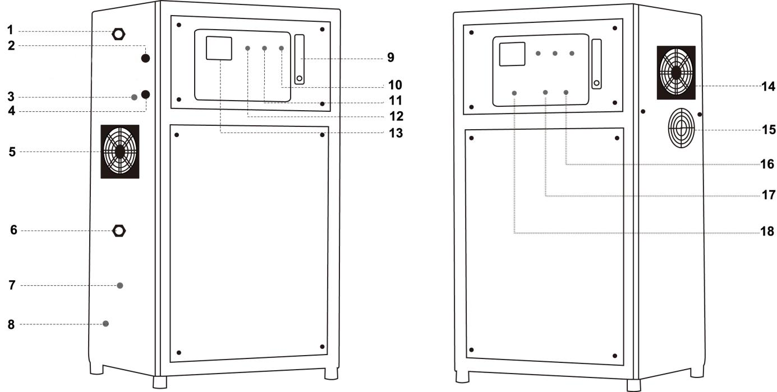
- Cooling water outlet
- Fuse
- 4-20mA signal inlet, control ozone concentration (optional )
- 220V Power cord
- Dust-proof net
- Cooling water inlet
- Ozone outlet
- Compressed gas inlet
9. Oxygen flow meter: ozone generator input gas flow displace
10. Air pump indicator( Red): the indicator lights up when equipment running
11. Running indicator(Green): the indicator lights up when ozone producing
12. Standby indicator( Yellow ): the indicator lights up when power on and standby status
13. Ampere meter
14-15. Cooling fan
- Air switch
- Ozone switch
- Ozone concentration adjuster ( Manual option )
4. Installation and maintenance
4.1 Installation place requirement

- Equipment should be installed indoor with clean, adequate light and good air circulation environment. It’s prohibited to be installed in the environment of exposure to sunlight, rain, water vapor, moisture, corrosive gas, explosive gas and dust.
- Environment temperature should be lower than 40℃, humidity lower than 70% (preferably, install air conditioner for cooling and drying). Environment temperature too high may lead to equipment cease and lower ozone production. High humidity may lead to controlling circuit malfunction or damaged.
- The distance between equipment and wall, ceiling should be more than 600mm, which is convenient for future maintenance.
- Equipment should be installed on solid, horizontal ground, installing on uneven ground may lead to a high level of equipment noise and vibration.

4.2 Piping installation

- Cooled water pipe： 1/2” PVC water pipe
- Ozone output pipe ：it must be connected with teflon hose come with the ozone generator or stainless steel pipe.

4.3 Electrical connection

- The power source should meet voltage and frequency requirement
- The voltage fluctuation can not be too high, and it should be within the range of -10% - +10% of the nominal voltage. It can not be used if voltage is out of range. Otherwise it will cause equipment damage, and voltage stabilizer or regulator should be used to meet the voltage range.

4.4 On/ Off procedure

- Check whether equipment connect cooling water piping, ozone output teflon tube correctly. 4-20mA control signal cable are in good connection ( for customized machine only), whether power source meet the equipment voltage requirement.
- Plug in power. Turn on the cooled water first, turn on air & ozone switch manually, manually adjust ozone concentration, Adjust oxygen flow meter to specified location.
- Show down operation: Adjusting ozone concentration to minimum , turn off air switch first, then turn off ozone switch. Cut off cooling water. Unplug if long time no use.

Warning :

- Prohibited to running the ozone generator without cooling water
- Prohibit to close output of water pump when the ozone generator & pump is running ( back water may go into the ozone machine cause damage )
- Teflon tube should place at the height of 1.5 meter from water level to prevent back water
- It is recommend to use an fan to cooling work shop if continuously running for over 4 hours.
5、Warranty and Maintenance
5.1 Warranty terms:

Thank you for choosing our products. To ensure you enjoy the perfect after-sale service from us, please read through this manual carefully after receiving the product, and keep it properly.

All products (not including consumable material, accessories ) from us are warranted for one year and lifetime maintenance from the date of purchasing.

The following occasions are excluded from the warranty, and we may charge for the repairing materials.

(1) Damage due to natural disaster or other majeure reasons;
(2) Product damage by human during transportation;
(3) Product damages due to unauthorized operation unless instructed by us or authorized distributor;
(4) Product damages due to high humidity working environment or flooded by water;
(5) Fail to provide proof of purchase or warranty card.

If on-site service is required, customer will be required to pay for the cost of traveling, and we or distributor can decide to come or not according to the distance.

In the case of sterilization standard is not met due to improper operation or malfunction of the product, Qili does not take any responsibility.

5.2 Maintenance

(1) Fan filtering net cleaning/replacement: the dust net needs regular cleaning due to accumulate dust from the air (refer to the maintenance cycle table below). Turn off the power before cleaning, and take off the cover of the fan. Then take out the stainless steel fan filtering net, clean it with clean water, and do not re-assemble it until it is dry.
(2) High voltage parts water removal: during humid season, there is moisture on connecting cable of the transformer (the high voltage unit), transformer, and the connecting cables of the ozone module. Dry it with cloth and hair dryer. Otherwise, it may lead to damage of the equipment.
(3) Ozone module inner chamber, discharge tube cleaning/ replacement: accumulate small partialon the inner chamber and electrode from the gas source will lower the ozone production and concentration. Hence, they need to be cleaned regularly.

5.3 Maintenance cycle table

Item | Content | Circle |  |  |  |  | Remark
 |  | month | Half year | One year | Two year | Three year
Fan filter net | Clean  replace | ☆ |  | ● |  |  | Cycling clean
Dry moisture on high voltage parts | Clean | ☆ |  |  |  |  | Maintain during humid season
Inner side of internal and external electrode | Clean |  |  | ☆ |  |  | Regular clean when used in beverage and food industry
Internal electrode | Replace |  |  |  | ● |  | Replace if high demanded
External electrode | Replace |  |  |  |  | ● | Replace if high demanded

Note:
(1) ☆：means inspection, adjust or clean; ●：means replacement
(2) The above table is the suggested maintenance/ replacement cycle from manufacturer and customer can also conduct the maintenance/replacement according the actual operation environment and intensity of work
(3) All maintenance/replacement can only be conducted when the power is off and pressure release,ensuring the safety of the operation personnel.

5.4 Trouble analysis and inspection

Number | Problem | Analysis | Inspection
1 | No power | 1、Power plug loose  2. No power from power socket  3. Fuse burn | 1、tighten plug  2、input right voltage  3、replace fuse
2 | No flow from ozone outlet | - Gas source is  - not connected  - Internal piping leakage  - Internal piping folded | - re-connect gas source  - reconnect the piping  - Check if there is leakage in the connectors,and tighten it if any is found
3 | Water store inside machine | - backwater into machine  - High humidity | - dry inner machine  - Adding air dryer
4 | Equipment | - Over temperature/heat  - Over load | - Change cooling fan for pcb or install air conditioner  - Low down the load

Note:

If the problem still exists after the above inspection, please contact our company or local distributor.
All maintenance/replacement can only be conducted when the power is off and pressure released,ensuring the safety of the operation personnel.
Appendix .（Oxygen Feeding Ozone Generator Electrical Diagram）

