CAUTION: READ INSTRUCTIONS THOROUGHLY BEFORE OPERATION OF UNIT

Oxygen Generator

Manual

Manufacturer：Guangzhou Qili Environmental Equipment Co.,Ltd

Add：No.39,Sanheng Rd,Huanjiao,Shijing Str,Baiyun Dist,Guangzhou

Phone：+86-020-37324923 Email: qlozone@qlozone.com

Web: www.qlozone.com
Dear Customers,

Many thanks for your choice of Qili oxygen generator. Your satisfaction is our continuous motivation, we will provide you with the best service from beginning to end. Qili series product come with high quality and good performance. In order to facilitate your usage, please carefully read this manual carefully before operation. Welcome to inquire and provide valuable advice, if you have any questions. Because of possible product improvements, your purchase product’s introduction maybe not completely consistent, hereby apologize.

Safety Notes
- Qualified special ground cable, reliable grounding, and safety grounding are required, otherwise electric shock and other dangers may occur
- The equipment can not be installed in area with high moisture or smoke, to avoid potential danger.
- Unauthorized disassemble, movement and reassembly are prohibited.
- The equipment can only be installed by qualified personal.
- The equipment must not be installed in area with risk of Ammonia leakage or explosion.
- Don’t use any damage parts, otherwise it may lead to accidents or damage to the device.
- User must not change electrical cables or power connector unless authorized.
- installation personal must be qualified technician and maintenance personal must be trained.

Operation Notes
- Don’t not rinse the equipment
- Make sure the drain valve are working normally, and filters with regular maintenance
- Keep the ambient area clean, dry , with ventilation device installed.
- Don’t damage the wiring cable, otherwise it will occur electric shock.
- Inlet and outlet must not be blocked; otherwise equipment performance will be lowered and out of order.
- Keep the external of the equipment clean.
- During long non-operation period, the power source should be disconnected and the equipment should be cover with plastic sheeting.
- To ensure safety, maintenance can only be conducted with equipment power off.

Operation Environment
(1) Ambient temperature：-10℃~37℃；
(2) Ambient humidity：≤70%；
(3) There shall be no flammable and explosive gas and conductive powder dusts in the room. It’s not permitted to install the equipment in a place where alkaline air is easy to leak or with risk of explosion.
(4) The ground for equipment installation must be horizontal, and the equipment shall be placed on ground or supports steadily.
(5) There must be draft fan or air conditioner to keep air dry and the operating
environment in good ventilation.
Product Description

Qili oxygen generator apply PSA technology,provide a cost-efficient source of oxygen.it’s safe ,more economical and convenient to use, which is widely used in agriculture, pharmaceutical production, water treatment, glass manufacture and ozone production.This product have been designated product for many domestic and international well-know company.

Characteristic
(1) PSA technology with imported oxygen molecular sieve
(2) 304 stainless steel housing, atmospheric and beautiful, durable;
(3) High conversion efficiency, low energy consumption, long service life;
(4) High concentration up to 95%,stable and continuously working
(5) Domestic patent product
(6) Silence working, low noise
(7) Plug and play ,
Technical Parameters
Item | Unit | QLY-3L | QLY-5L | QLY-8L |  | QLY-10L | QLY-15L | QLY-30L
Oxygen output | LPM | 3 | 5 | 8 |  | 10 | 15 | 30
Oxygen concentration | % | ±95%
Pressure(outlet) | Mpa | 0.06-0.08
Temperature | ℃ | indoor temperature
Relative humidity | % | ≤ 70%±10%
Noise | Db | ≤60 | ≤60 | ≤60 | ≤60 |  | ≤60 | ≤60
Dimension | mm | 500*400*530 | 500*400*630 | 500*400*730 | 500*400*830 |  | 500*400*1350 | 400*500*1400
Net weight | kg | 24 | 29 | 37.5 | 40 |  | 62.6 | 115

Note: Technical parameters listed above may be deviation for different location

Control Panel Description
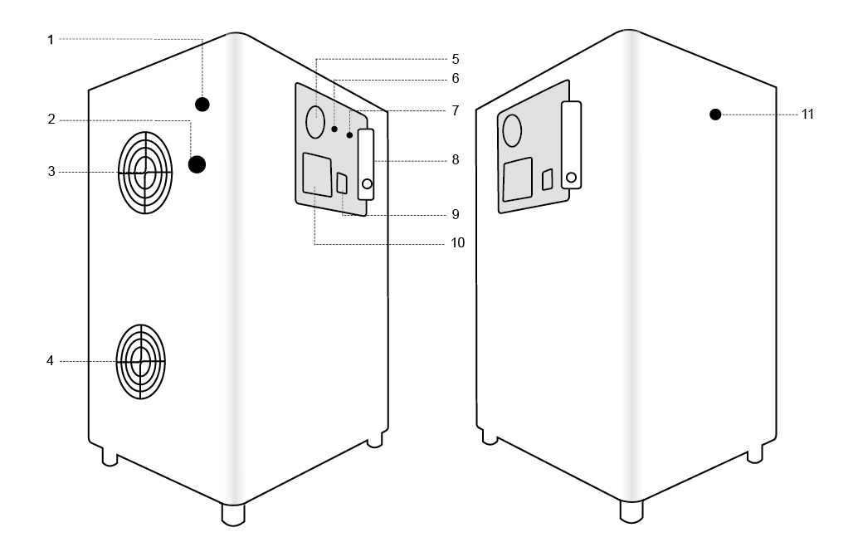
1. Fuse | 7. Power indicator
2. Power cord | 8. Gas flow meter
3. Cooling fan | 9. ON/OFF Switch
4. Cooling fan | 10. Ampere meter
5. Pressure gauge | 11. O2 outlet
6. O2 indicator

Electrical Connection
- The power source should meet voltage and frequency requirement
- The voltage fluctuation can not be too high, and it should be within the range of -10% - +10% of the nominal voltage. It can not be used if voltage is out of range. Otherwise it will cause equipment damage, and voltage stabilizer or regulator should be used to meet the voltage range.
On/ Off Procedure
- Plug in AC 220V/50Hz
- Turn on POWER switch, power & O2 indicator lighting ,The ampere meter indicates the current , pressure gage indicate oxygen input pressure. Adjust oxygen flow meter to specified scale, it start to produce oxygen.
- After finish use,turn off POWER switch .Unplug if long time no use.

Maintenance
1. Check every month that the two front cover LED’s are illuminated when the generator is on.
2. Remove the black cover on the fan air inlet and air outlet. Clean the air filters with hot water every month.
Warranty
All products ( not including consumable material, accessories ) from Qili are warranted for one year and lifetime maintenance from the date of purchasing.

The following occasions are excluded from the warranty, and Qili may charge for the repairing materials.

(1) Damage due to natural disaster or other majeure reasons;
(2) Product damage by human during transportation;
(3) Product damages due to unauthorized operation unless instructed by Qili or authorized distributor;
(4) Product damages due to high humidity working environment or flooded by water;
(5) Fail to provide proof of purchase or warranty card.

If on-site service is required, customer will be required to pay for the cost of traveling, and Qili or distributor can decide to come or not according to the distance.

Product name
Model |  | User info.
Purchase date |  | Purchase quantity
Address |  | Phone

