Operating Manual

Cash Disinfection Cabinet

1.Introduction to the sterilization process of ultraviolet ozone disinfection cabinet：

Ultraviolet ozone disinfection cabinet sterilization refers to the ultraviolet radiation through the wavelength sterilization and internal tube generator produced by the ozone with strong oxidation of the double sterilization.Ultraviolet sterilization in the UV-C band: 250-270nm range of the strongest sterilization.Ozone is the world's second largest strong oxidant, its strong oxidation ability can effectively oxidize and inactivate bacteria and viruses, inactivation rate as high as 99.28%.Ultraviolet sterilization lamp can produce 254nm ultraviolet wavelength, tube generator produces 15-25mg/L high concentration of ozone, so that bacterial and viral DNA and RNAV denaturation, cells can not reproduce, the sterilization of the broad spectrum is the highest, it can kill almost all bacteria, viruses can be efficient, disinfection is not required to add any chemical agents.Ozone ultraviolet sterilization is effective for any bacteria or virus, concentrated high intensity ozone and ultraviolet irradiation can be sterilized within a short time, a long time of ozone and ultraviolet irradiation can kill more than 99.9% of the bacterial bud on the surface of the object, bacterial reproduction can be killed only 1s.

1. Product Parameter

|  |  |  |  |  |  |  |
| --- | --- | --- | --- | --- | --- | --- |
| Model | Volume | Size | Voltage | Ozone Concentration | Work Environment | Power |
| QL-S-40L | 40L | 400*300*600 | 220v/60hz | 15-25mg/L | 0-40℃ | 80W |
| QL-S-80L | 80L | 450*300*900 | 220v/60hz | 15-25mg/L | 0-40℃ | 130W |
| QL-S-100L | 100L | 450*350*1000 | 220v/60hz | 15-25mg/L | 0-40℃ | 150W |
| QL-S-500L | 500L | 500*800*1600 | 220v/60hz | 15-25mg/L | 0-40℃ | 250W |

3. control Panels Introduction

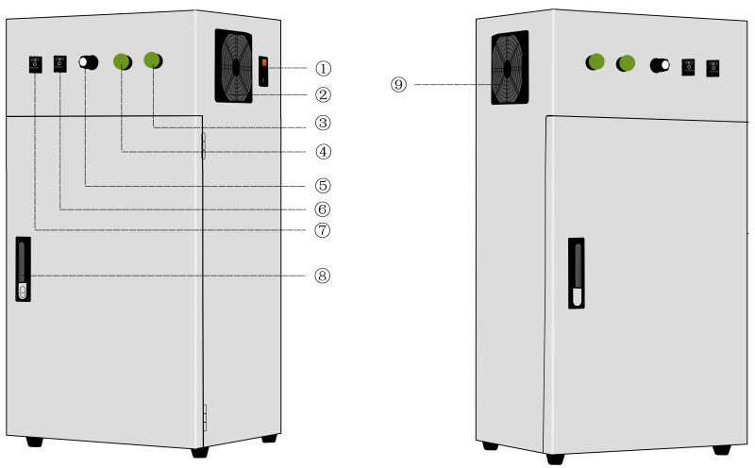

①power switch ②cooling fan ③ozone indicator light ④UV indicator light ⑤timer ⑥ozone switch ⑦uv lamp switch cabinet door switch ⑧cooling fan

4.First Start

Should dip in the inside of ark body with clean terry cloth first a few alcohol and lamp tube are wiped, wait for alcohol volatilize hind can use, after closing the door to plug in power, press ozone and ultraviolet open key to be disinfected.

1. Operating Instruction

1: before disinfection, put the items to be sterilized into the disinfection cabinet. The humidity of the items should not be too large.

2: connect the power supply of 220v/50hz, turn on the ozone switch and the uv light switch of the disinfection cabinet, turn on the timing knob after the corresponding indicator light is on, the equipment is started and disinfection begins;

3: timing disinfection 30-60min (or according to the specific disinfection items to choose the disinfection time), after disinfection timer off automatic shutdown, shut off the ozone switch and uv switch, the equipment is completed shutdown, shutdown is not recommended to immediately open the cabinet door, can be closed cabinet door 15-30min, take out the items.

1. Attention

1: do not touch the ozone ultraviolet lamp tube directly, do not look directly during disinfection, do not directly irradiate the skin, so as to avoid damage;

2: do not open the disinfection cabinet in the process of use, otherwise it will lead to ozone leakage, human inhalation of a certain amount of words will damage the respiratory tract;

3: the object should be 10 cm away from the ultraviolet lamp when it is disinfected;

4: the air should be less dust, clean, no acid, no alkali components;

5: working environment humidity < 80%, humidity < 40℃, no flammable gas, no flammable substances.

1. Common Failure Analysis

|  |  |  |  |
| --- | --- | --- | --- |
| Fault Type | Analysis of causes | Treatment measure | remark |
| Non-energized equipment | 1. The power plug is not plugged in properly  2. The voltage level does not meet the requirements  3. Fuse is blown | 1. The power plug is not plugged in properly  2. The voltage level does not meet the requirements  3. Fuse is blown |  |
| Chassis charged | 1. The ground wire is not firmly connected  2. The working environment is too humid | 1. Check the grounding wire and tighten it  2. Use in a dry and ventilated environment | This operation must be handled in the event of a power outage |
| No ozone output at outlet | 1. Ozone switch is not started  2. The time switch is not open  3. Ozone module is damaged | 1. Turn on the ozone switch  2. Rotate the time switch  3. Replace ozone generation module |  |
| Blown fuse | 1. Too high voltage  2. Short circuit  3. Ozone module is damaged | 1. Check the power supply  2. Check internal circuits  3. Replace ozone generation module |  |
| The water in the oven | 1. The air is moist  2. Air source is not dried | 1. Blow dry the standing water  2. Air source drying treatment | This operation must be handled in the event of a power outage |

1. Maintenance regulation

The company's series of products from the date of your purchase, in addition to wearing parts, to provide a one-year free warranty, if the product appears the following failure, the company will no longer assume the free warranty obligation, will charge a certain maintenance fees and material fees:

1. Product damage caused by natural disaster or other force majeure;

2. Product damage caused by people during transportation;

3. Damage caused by unauthorized modification of product structure and improper operation;

4. Product damage caused by improper storage by the user, too wet (humidity ≥ 75%) or water in the machine;

5. Failed to provide valid purchase voucher.

9.Disclaimer

1. Users of this product must carefully read this operation manual before operation. The company shall not assume any responsibility for economic losses or personal safety accidents caused by improper operation, unauthorized disassembly or modification of this product.

2. The company shall not assume any responsibility for economic losses and personal safety accidents caused by force majeure (earthquake, flood and other natural disasters).

**Warranty Card**

|  |  |  |  |
| --- | --- | --- | --- |
| Purchaser |  | Purchase Date |  |
| Contact Person |  | Telephone & Email |  |
| Address |  | Post code |  |
| Product Name |  | Series Number |  |
| Client Signature |  | Distributor Signature |  |

Please fill in the table and send the card to our company.

After receiving this form,we will confirm to you and the warranty is valid